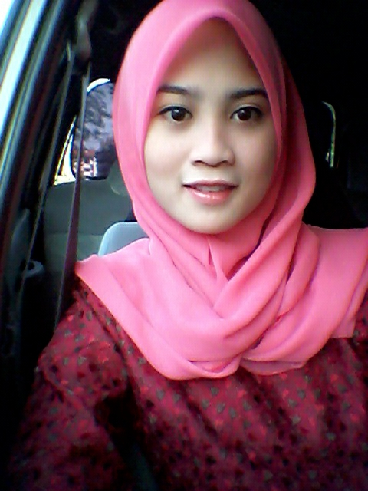

OBJECTIVES

Seeking a challenging opportunity with your organization where my knowledge, skills and experience can be extensively applied.

PERSONAL INFORMATION

Name | : Suzi Binti Moh Apandi
E-mail | : suzimohapandi@gmail.com
NRIC | : 910414-01-5134
Gender | : Female
Marital Status | : Single
Race & Religion | : Malay & Islam
Contact Address | : Pos 14, Parit Nawi,  Parit Jawa,  84150 Muar, Johor.
Telephone | : (H/P)017- 363 9397
EDUCATION BACKGROUND
2010 - 2012 | Diploma in Civil Engineering
2010 - 2012 | Politeknik Port Dickson  Last CGPA 3.12
2007-2008 | Sek Men Teknik Muar  SPM ( Past all subject)

CURRICULUM ACTIVITIES

Politeknik Port Dickson
2012 ( Jan ) : Joint Mandate of The Honorable Minister of Higher Education at PICC Putrajaya
: Attend Camp Leadership and Self-esteem at Pulau Pangkor

( Jun ) : Student Representative Council Secretary

( Sep ) : Represent a theater competition in “ Festival Kebudayaan dan Warisan Polytechnic Malaysia 2012 ”

( Dec ) : Attend IBS programmer for (Roof Trusses, Precast Concrete, Japanese Grill and Window Door Frame )

2011 ( Jan ) : Attend Discretion Youth Program organized by “ Jabatan Hal Ehwal Agama Islam Negeri Sembilan ”

( Dec ) : Student Representative Council Clubs and Association Executive

2010 ( Jan ) : A member of Poly-Briged at Port Dickson Polytechnic

( Jun ) : Basketball club vice-chairman of Port Dickson Polytechnic
: College player for netball in the intercollegiate sports carnival at Port Dickson Polytechnic

SKILLS

Computer Knowledge : Advanced skills in Word Processing, Microsoft Excel, Access, Power Point

Communication Skills : Written Spoken

Bahasa Melayu Excellent Excellent
English Moderate Moderate

WORKING EXPERIENCE

THRIVEN GLOBAL BERHAD

Jun 2015 – Current

Project Secretary (E7) – Project Management & Implementation

Working Project Experiences

- Ensure establishing standard, maintained records, systematic and efficient filling system is in place for easy retrieval by the Project Team
- SharePoint ;Document and drawings upload/ monitor for Project Department
- Support to prepare the document, correspondence, sort of memo, take minutes of meeting and undertake any ad-hoc admin for Project team as required ensure that all requests are addressed in an efficient and expedited manner
- Ensure all ongoing project have the latest drawing with all the updated drawing list and ensure RFI update
- Monitoring all incoming/ outgoing correspondence in circulation
- Provide full secretarial and admin support to the project team and department to ensure the smooth running of the department operations
- Develop and maintain document control processes for the efficient management
- Undertake any ad-hoc admin projects / duties as required
- Coordinate travel arrangements inclusive of air-ticket, hotel accommodation, claims
- Assist to check and verify staff claims and invoices for project team

MUDA BERJAYA SDN BHD

August 2014 – Jun 2015

Assistant Engineer

Project Mass Rapid Transit Lembah Kelang : Jajaran Sungai Buloh – Kajang

Package S3 – Construction and Completion of Elevated Stations and Other Associated Works At The Curve, One Utama and Taman Tun Dr Ismail

Working Project Experiences

- Monitoring day to day site activities on all installation works related to all services
- Attending Site Progress Meeting to report on the work progress
- To prepare site progress report
- To coordinate all works with other works disciplines
- Carrying out task assigned to you by the Director or Manager
- Liaison with Clients having jurisdiction for the entire projects
- Coordinate all quality related correspondence with the customers representatives
- Action and close all customer complaints
- Monitor all quality related activities on the project
- Monitor QC works

ASIAN BROADCASTING NETWORK SDN BHD

April 2013 – August 2014

Executive – Permitting & Compliance Department
Working Project Experiences
Handle full project involve at area Klang Valley and Negeri Sembilan
- To facilitate right of way and civil work permit from the local council and state government agencies
- Liaise and built PR with the local council and state government agencies
- To submit TNB poles application and follow up TNB permit from the TNB Branch
- To organise and perform joint site visit with TNB Branch
- Facilitation of TNB power and meter application from the TNB Branch
- Inspection and verification of the new hub boundary & hub site
- To organise joint site visit with the local council for close permit files and recovery the security deposit
- Updating the permitting & compliance tracker
- Checking & updating smart sheet from time to time
- Supporting administrative work
- To perform any job assign from the superior from time to time

PERSONAL CHARACTERISTICS

- Team player, creative and good communication skills.
- Good leadership, motivation and project management.
- Good analytical competency and time management
- Independent, aggressive and spontaneous.
- Able to work independently as well as in group
- Able to control my emotions well and can work under any circumstances/pressure
- Able to learn fast
- Self-confidence

REFERENCES

1. Name : Mr. Haizal Bin Ismail
Mobile Phone : 012 - 602 1209
Position : Lecturer at Port Dickson Polytechnic
Organization : Politeknik Port Dickson

2. Name : Mr. Mohd Helmi Bin Jamil
Mobile Phone : 012 – 367 1703
Position : Senior Executive, HR & Admin
Organization : Thriven Global Berhad

